MODEL RECOMMENDATION SYSTEM - LOGIC & FLOW REFERENCE

- System Overview
The Model Recommendation System is an intelligent LLM dispatcher. Instead of sending every request to the same model, it:
- Reads a config defining available models, groups, and task types (use-cases)
- Checks which models are online
- Filters out models that fail hard requirements (quality, context, cost)
- Adjusts scoring priorities based on urgency
- Picks the highest-scoring model
- Runs the model and falls back automatically if it fails

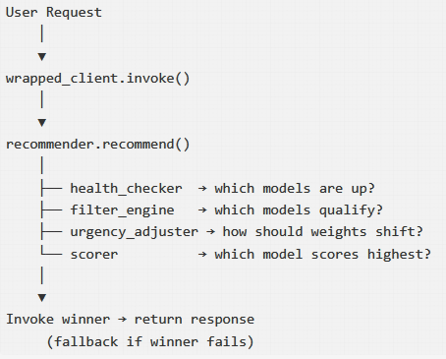
Fig 1. System Overview

- Config Structure (Quick Reference)

config.json has 4 top-level sections:
Section | What it defines
models | Each model’s id, name, provider, and metadata scores/tags
groups | Collections of models with a routing strategy (priority / round-robin)
use_cases | Task types with weights, minimum requirements, preferred tags, and fallback group
settings | Global switches: health check toggle, timeout, tag bonus, score threshold, log path

Validation rules enforced at load time: - All scores (quality_score, latency_score, cost_score) must be 0.0 – 1.0 - context_length must be > 0 - Use-case weights must sum to 1.0 - routing_strategy must be "priority" or "round-robin" - Model IDs referenced in groups must exist in models; fallback groups referenced in use-cases must exist in groups

- Module 1 - config_loader

Role: Load config.json → validate everything → return a structured RouterConfig object.
Parsing flow
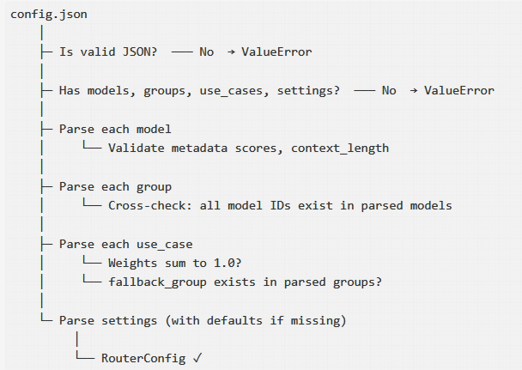

Dry Run: Your config.json

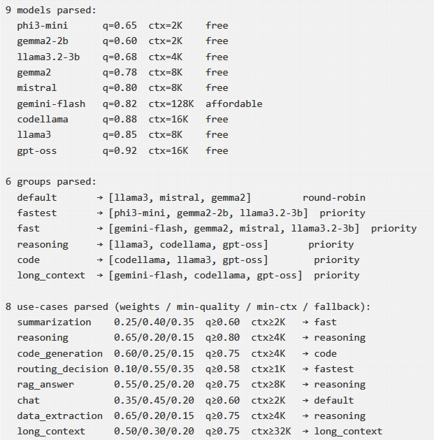

- Module 2- health_checker
Role: Ping all models simultaneously → return a {model_id: bool} health map.
Logic
- If health_check_enabled = false in settings → skip pinging, mark all as healthy (useful for testing)
- Otherwise, fire async HTTP requests to the Ollama API (/api/tags) for all 9 models at the same time
- For each model, check if its model_name appears in the Ollama list
- Any model that doesn’t respond within health_check_timeout_seconds (3s) is marked offline

Dry Run Output
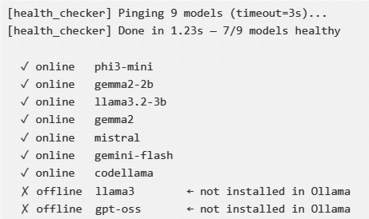
This map flows directly into the filter engine.

- Module 3 - filter_engine
Role: Apply 4 sequential hard filters to eliminate models that cannot fulfill the request.
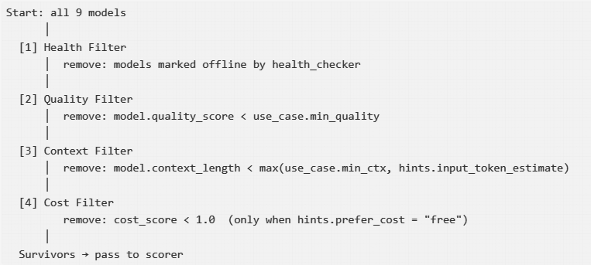
Key insight: Filters are fast, cheap rejections that prevent the scorer from wasting work on unqualified models.

Filter Logic Details
Filter | Condition to survive | Config source
Health | health_status[model.id] == True | health_checker output
Quality | model.quality_score >= min_quality | use_case.minimum_requirements
Context | model.context_length >= required_ctx | use_case.minimum_requirements + runtime hint
Cost | model.cost_score == 1.0 (only if prefer_cost=“free”) | runtime hint

Dry Run: code_generation use-case
Setup: health check passed for 7 models (llama3, gpt-oss offline); min_quality=0.75; min_ctx=4096; no cost preference
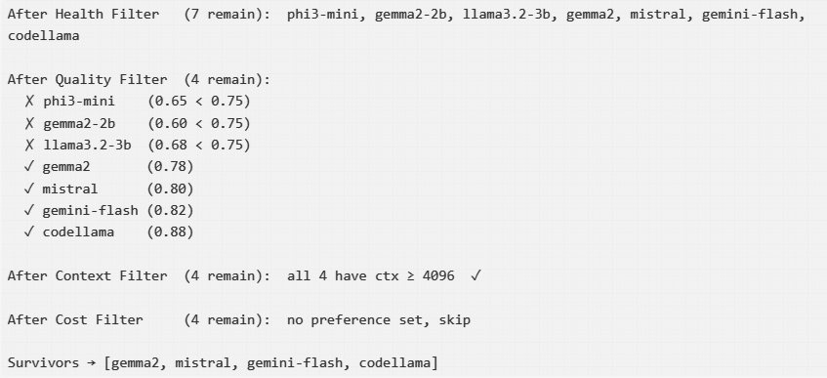

6. Module 4 — urgency_adjuster
Role: Shift the quality/latency trade-off weights based on how urgently the user needs a response.

Shift Rules
Urgency | Quality shift | Latency shift | Cost shift
high | −0.25 | +0.25 | 0
normal | 0 | 0 | 0
low | +0.20 | −0.20 | 0
Cost weight never changes. Only quality and latency are traded off.
After shifting, weights are clamped to [0, 1] and renormalized so they still sum to 1.0.
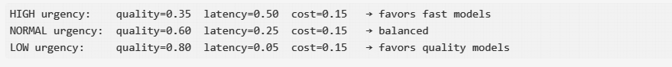

7. Module 5 — scorer
Role: Score each surviving model using the adjusted weights and tag matching, then rank them.

Scoring Formula
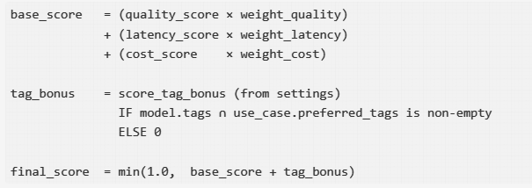
Tag bonus is flat (all-or-nothing): 1 matched tag = same bonus as 3 matched tags. It rewards specialization, not quantity.

Dry Run: code_generation, normal urgency
Weights: quality=0.60, latency=0.25, cost=0.15
Tag bonus: 0.05 (if any preferred tag matches)
Preferred tags: ["code", "reasoning"]
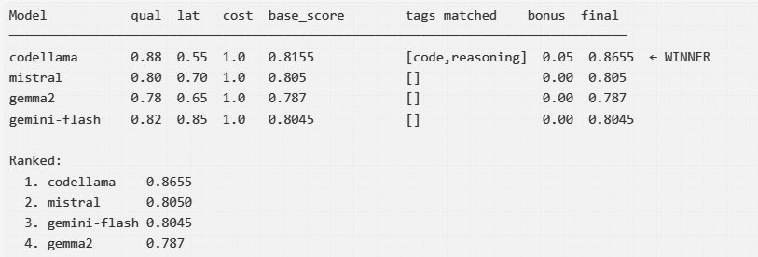

8. Module 6 — recommender
Role: The main orchestrator. Ties all modules together into one recommend() call.

Full Pipeline
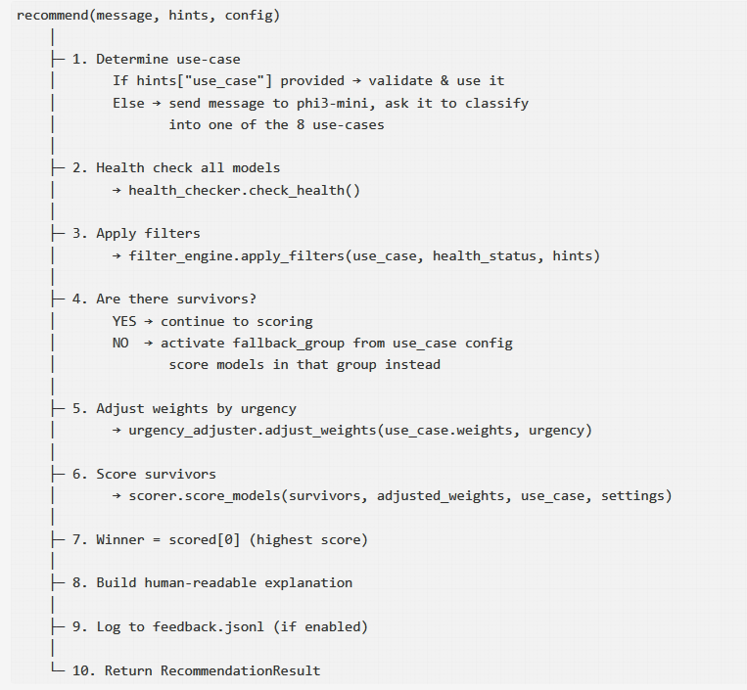

What RecommendationResult Contains
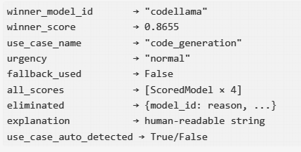

9. Module 7 — wrapped_client
Role: The developer-facing API. Hides all routing complexity behind a single .invoke() call.

Three Modes
Mode | How to create | Behaviour
MODEL_ONLY | from_model("codellama:34b") | Calls that model directly. No recommender. No fallback. Fastest.
CONFIG_ONLY | auto("config.json") | Full recommender pipeline. Picks best model automatically. Fallback enabled.
MODEL_CONFIG | from_model("codellama:34b", config_path="config.json") | Tries specified model first. If it fails, falls back to full recommender.

Invoke Flow (CONFIG_ONLY)

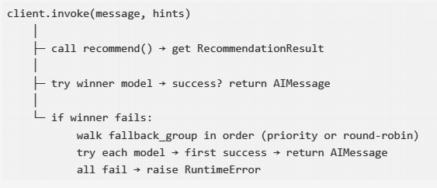

Routing Strategies (in Fallback Groups)
Priority — try in fixed order: model 1 → model 2 → model 3
Round-Robin — rotate starting point each call to spread load:
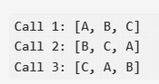

- Complete Pipeline
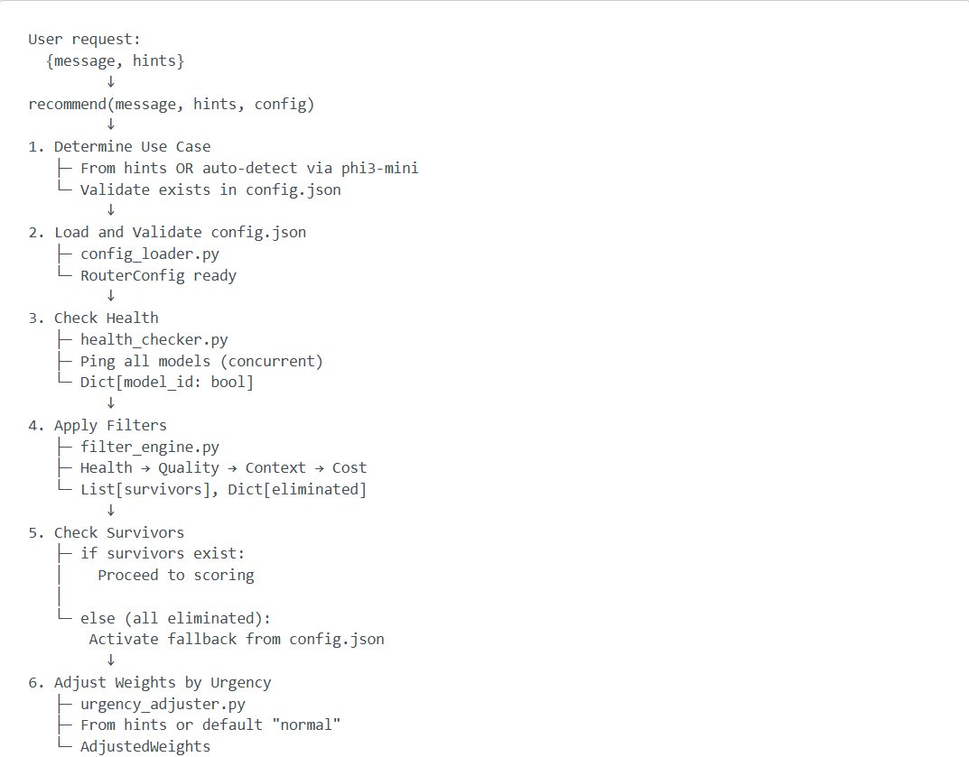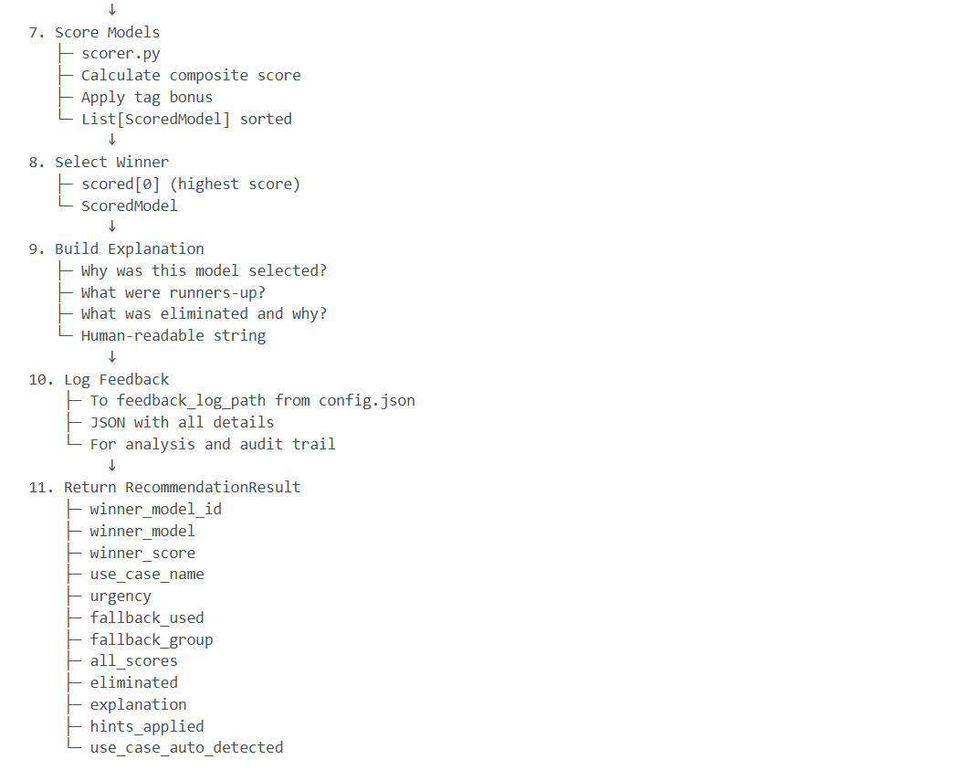
- Complete Example

Request
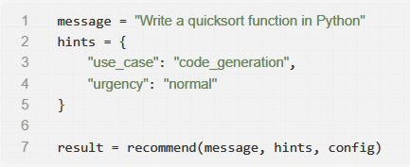
Execution
Step 1: Use case
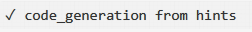
Step 2: Health check
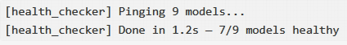

Step 3: Filter
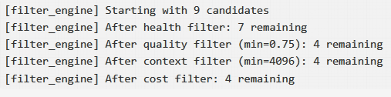

Step 4: Adjust weights

Step 5: Score
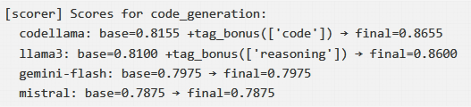

Step 6: Winner


Step 7: Explanation

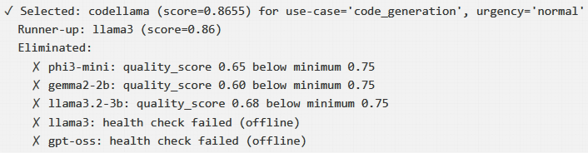
Step 8: Log

Step 9: Return
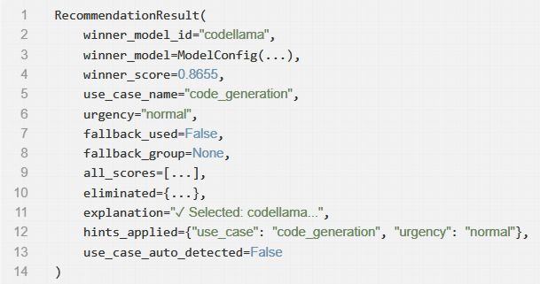

Fallback Scenarios
Scenario A — All models fail filters (strict requirements)
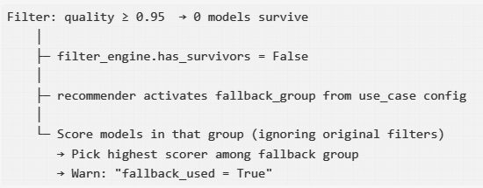

Scenario B — Winner model crashes at invoke time
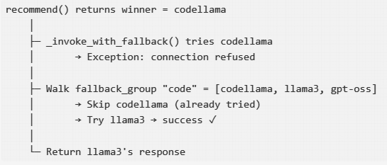

Scenario C — Everything offline (total outage)
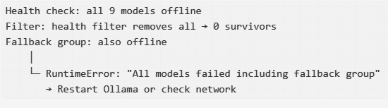

Scenario D — MODEL_CONFIG: preferred model fails
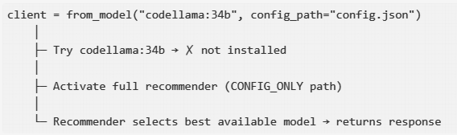

- Module Summary Table

Module | Input | Core Logic | Output
config_loader | config.json | Parse JSON, validate all rules, build dataclasses | RouterConfig
health_checker | All models + settings | Async-ping Ollama /api/tags for each model concurrently | {model_id: bool}
filter_engine | Models + health map + use-case + hints | 4 sequential hard filters (health → quality → context → cost) | FilterResult (survivors + elimination reasons)
urgency_adjuster | Base weights + urgency level | Shift quality↔latency, clamp, renormalize | AdjustedWeights
scorer | Survivors + adjusted weights + tags | Weighted composite score + flat tag bonus, sort descending | List[ScoredModel]
recommender | Message + hints + RouterConfig | Orchestrate all above modules; handle fallback group if no survivors | RecommendationResult
wrapped_client | Message + hints (+ config path or model name) | Route to correct mode (MODEL_ONLY / CONFIG_ONLY / MODEL_CONFIG), run LLM, chain fallback | AIMessage

Config.json Usage by Module
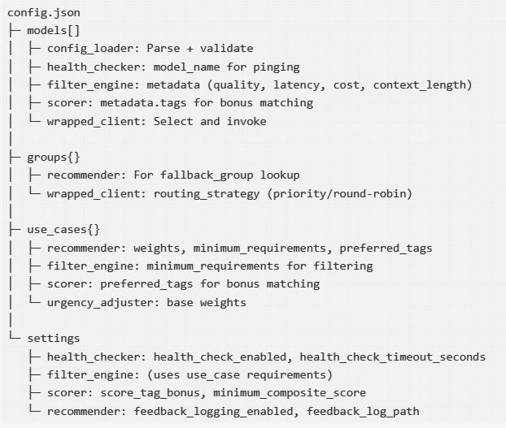
- Example Workflows

Workflow 1: Simple Code Generation
User: “Write a Python function for binary search”
Flow:
- wrapped_client.auto(“config.json”)
  - Load config.json
  - CONFIG_ONLY mode
- recommend(message, hints, config)
  - Use case: auto-detect “code_generation”
  - Health check: 9 models, 7 online
  - Filter: quality 0.75 → 4 survivors
  - Context 4096 → 4 survivors
  - Adjust weights: normal urgency → 0.60, 0.25, 0.15
  - Score: codellama=0.8655, llama3=0.86, gemini-flash=0.7975
  - Winner: codellama (0.8655)
- wrapped_client.invoke
  - Try codellama
  - Success ✓
  - Return response
- Log to feedback.jsonl
- {
"timestamp": "2026-03-26T...",
"use_case": "code_generation",
"winner": "codellama",
"winner_score": 0.8655,
"recommendation_time_ms": 245.3
}

Workflow 2: High-Urgency Summarization
User: “Summarize NOW!” + urgency=“high”
Flow:
- wrapped_client.auto(“config.json”)
  - CONFIG_ONLY mode
- recommend(message, hints={“urgency”: “high”}, config)
  - Use case: auto-detect “summarization”
  - Health check: 7 online
  - Filter: quality 0.6 → 6 survivors
  - Context 2048 → 6 survivors
  - Adjust weights (HIGH urgency): quality=0.10, latency=0.65, cost=0.25
  - Score (latency boosted): phi3-mini=0.76, gemma2-2b=0.77, llama3.2-3b=0.72
  - Winner: gemma2-2b (0.77) - fastest!
- invoke
  - Try gemma2-2b (fast)
  - Success ✓
  - Return response
Key difference: HIGH urgency selected fastest model (gemma2-2b) instead of highest quality (gemma2)

Workflow 3: Large Document with Fallback
User: “Process my 50KB document” + use_case=“long_context”
Flow:
- wrapped_client.from_model(“codellama:34b”, config_path=“config.json”)
  - MODEL_CONFIG mode (try model first)
- invoke(message)
  - Try codellama:34b
  - ❌ Server down (connection refused)
  - Fallback to recommender
- recommend (fallback)
  - Use case: long_context
  - minimum_requirements: context_length=32768
  - Health check: gemini-flash offline
  - Filter: context ≥ 32768 → gemini-flash(128K), codellama(16K), gpt-oss(16K)
  - ❌ Only gemini-flash survives but offline
  - Activate fallback_group “long_context”
  - Models: gemini-flash (offline), codellama, gpt-oss
  - Score: codellama=0.81, gpt-oss=0.79
  - Winner: codellama
- invoke with fallback
  - Try: codellama ✓ Success
  - Return response
- Log
- {
"fallback_used": true,
"fallback_group": "long_context",
"winner": "codellama"
}

Workflow 4: All Models Fail
Scenario: Ollama server crashed, all models offline
Flow:
- health_checker
  - Ping all 9 models
  - All timeout ❌
  - health_status: all False
- filter_engine
  - Health filter: all eliminated
  - FilterResult.has_survivors = False
  - Activate fallback_group
- fallback_group “code”
  - Models: codellama, llama3, gpt-oss
  - Health check: all still offline ❌
  - fallback_models = []
- Error
- RuntimeError: All models failed — including all models in fallback group 'code'.
Check that Ollama is running.
Fix: Restart Ollama server or reconfigure fallback groups

Workflow 5: Cost-Conscious User
User: “I want only free models” + prefer_cost=“free”
Flow:
- filter_engine
  - Cost filter: prefer_cost=“free”
  - Remove all models where cost_score < 1.0
  - From your config: all models have cost_score=1.0 ✓
  - All pass
- Score and select as normal
Note: In your current config.json, all models are free (cost_score=1.0), so cost filter doesn’t eliminate anything. If you added paid models (e.g., OpenAI with cost_score=0.5), this would filter them out.

